LC STM32 4G Dual Relay Development Board Air780e Module
LC-IOT-1025
AIR780E-4G module STM32 development board
Dual 5V relay

深圳市艾尔赛科技有限公司
Shenzhen LC Technology Co.,Ltd.
2024-04

About
The Air780e module of the LC STM32 4G dual relay development board uses STM32F103C6T6 as the main control chip, and is equipped with the Air780E LTE Cat.1 bis communication module launched by Luat Communication. It is a 4G full network and can adapt to different operators and products. By default, it uses AT firmware to communicate with STM32 through the serial port, and uses AT commands for networking data transmission and reception functions; The dual relay will open when powered on, and the product supports Type_C port+KF128 terminal power supply. The commonly used pins are basically all led out, which is convenient for secondary development.

View
①Front view
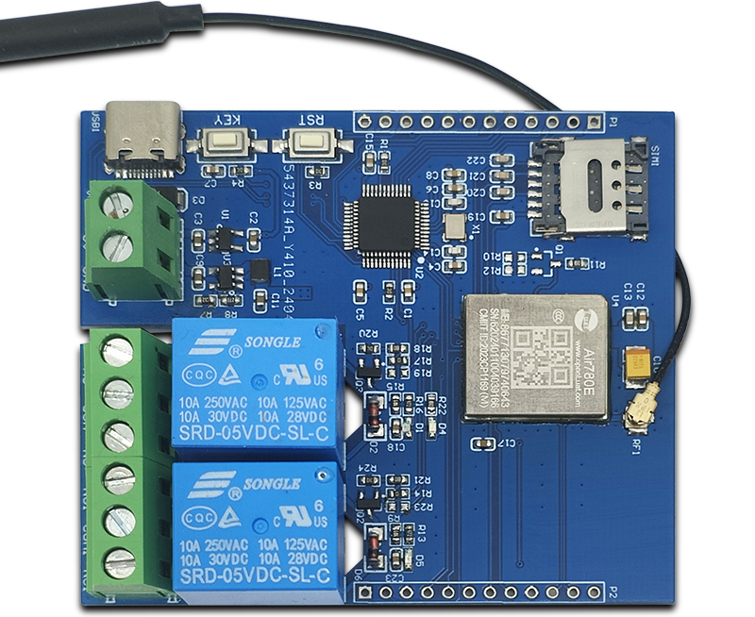

②Side view
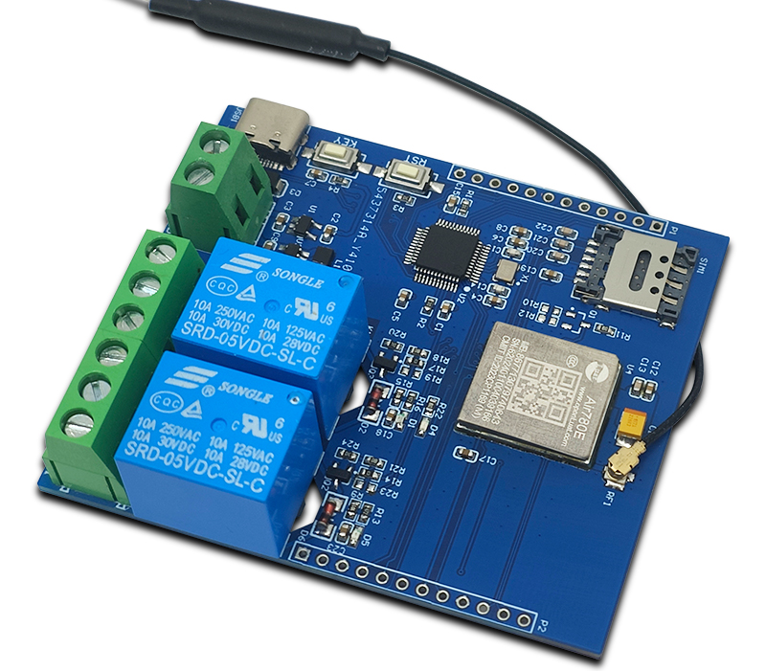
③Reverse image
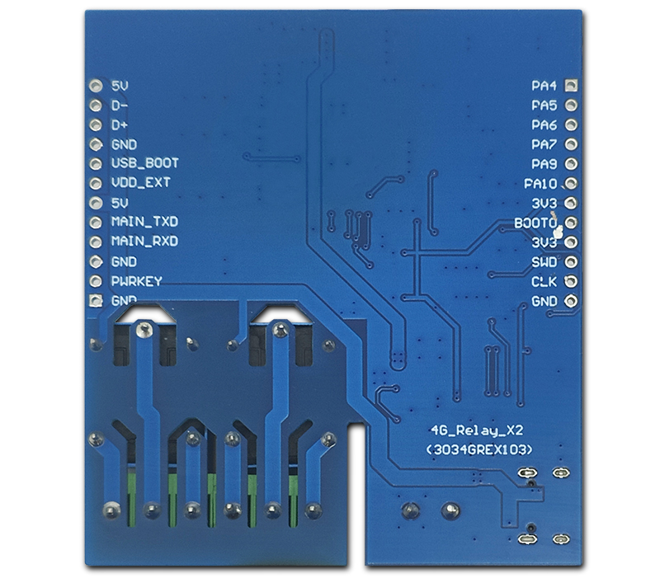

Functional Features
1. Using the mature and stable STM32F103 series 32-bit microcontroller, users can develop based on AT instructions or directly based on AIR780E;
2. Onboard AIR780E module, low power consumption, sleep power consumption as low as 600uA;
3. Flip up nano SIM card holder, easy to install and remove;
4. Onboard blue AIR780E network status indicator light;
5. Onboard reset button and user button, users can develop their own desired functions;
6. Supports Type-C power supply+KF128 terminal 5V power supply;
7. The commonly used IO ports of the microcontroller and AIR780E are mostly fully connected.

Introduction and Explanation
Board size：62*72.5mm/45 g
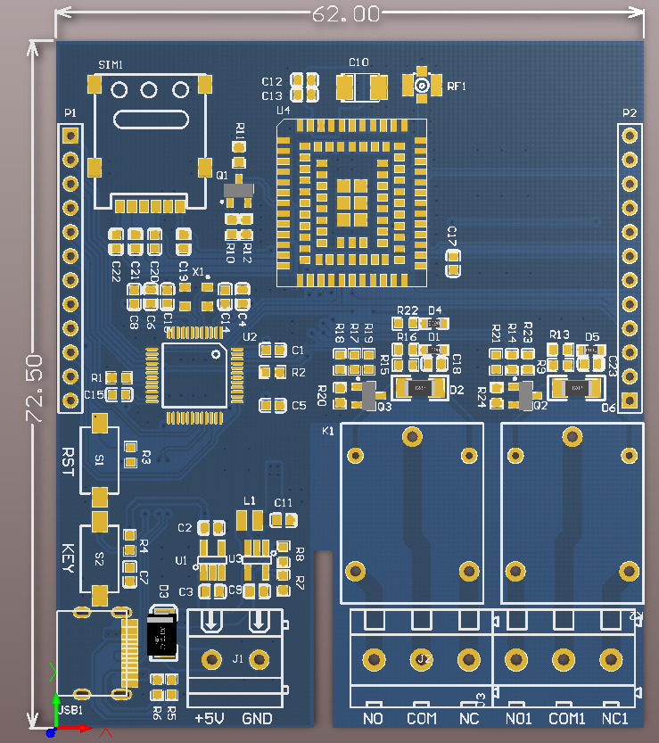

Interface Introduction
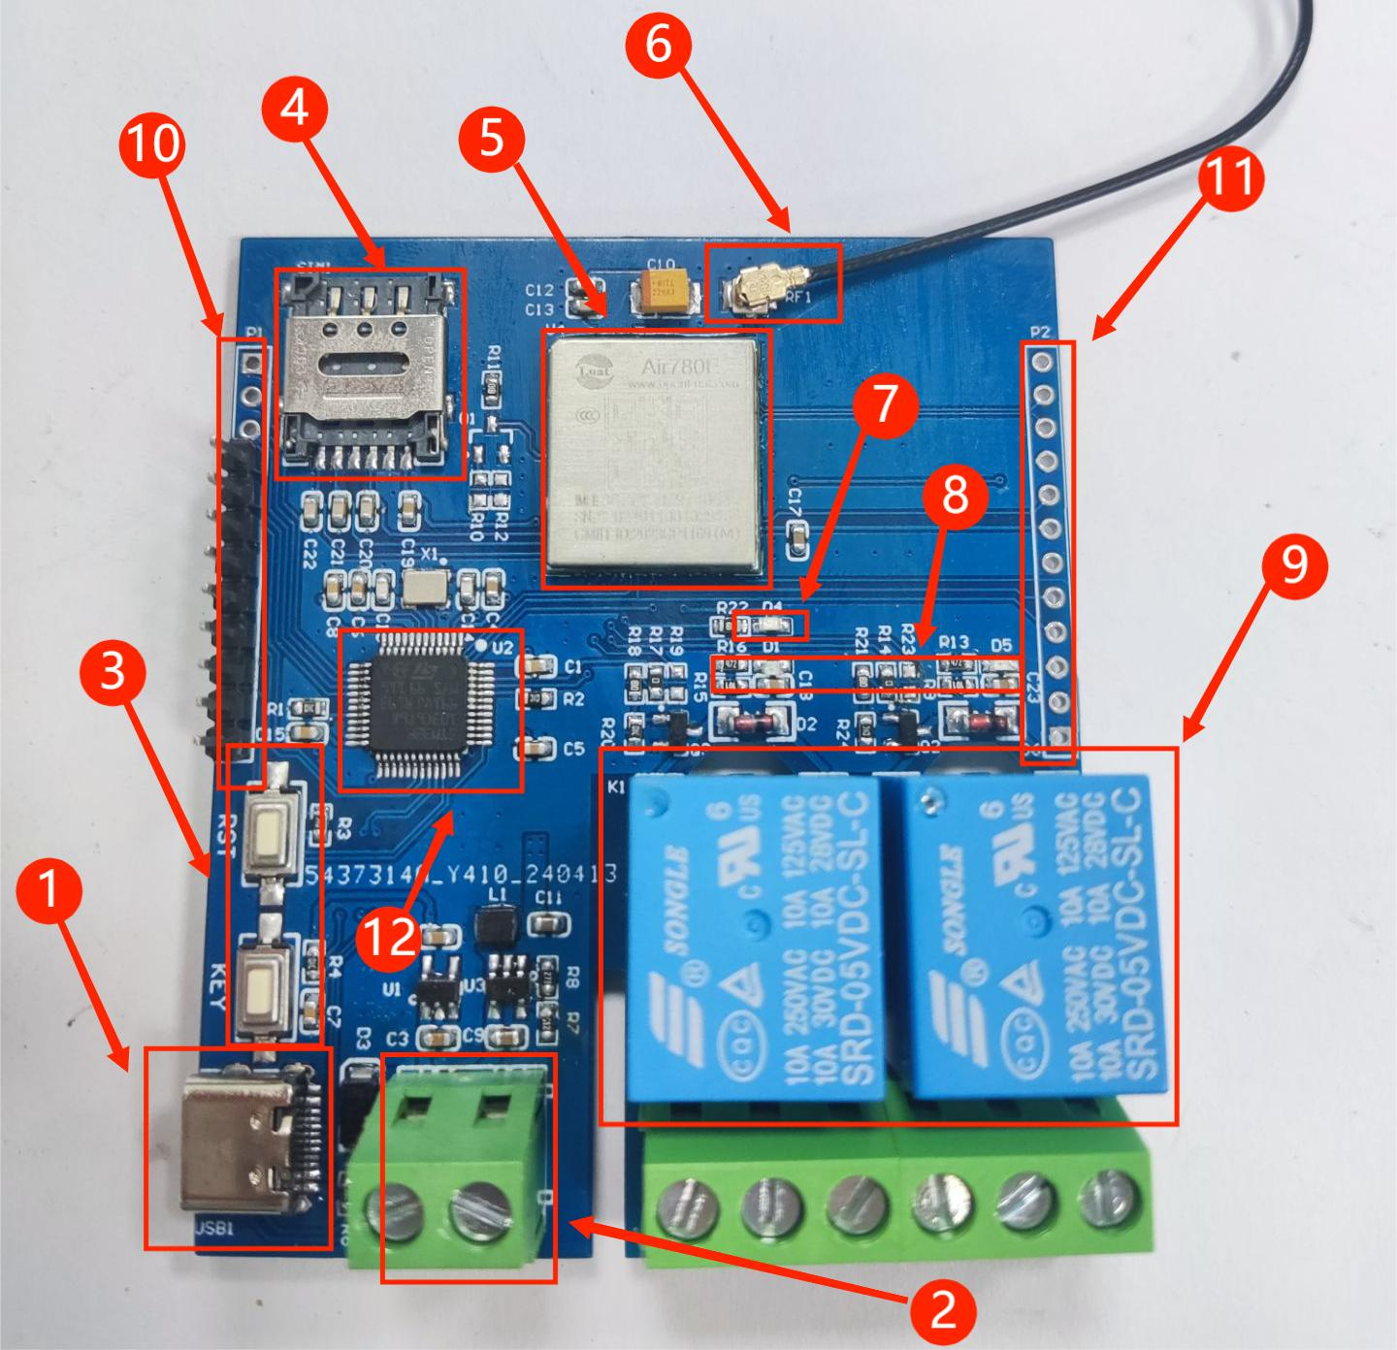
1. Type_C port: power supply+USB interface
2. KF128 power supply terminal: 5V power supply
3. Keys: RST reset key+KEY key (PB12)
4. Nano SIM card holder: When inserting the card with internet access, the power on relay will open
5. Air780e module
6. Antenna
7. Blue network status indicator light: It will repeatedly light up after power on, and will accelerate to turn on and off when there is a network
8. Relay status indicator light
9. Dual 5V relay
10. Common IO pins for STM32
11. Common IO pins for Air780e
12.MCU：STM32F103C6T6（LQFP-48）

Module usage instructions
- Program burning - USRT: Prepare a USB to TTL module (such as CH340) and plug it into the computer's USB port. The connection method to the module is as follows:

TTL Serial port module | 4G Development board
GND | GND
TX | RX
RX | TX
3.3V | 3.3V
Then plug in the jumper cap between the BOOT0 pin and 3.3V to burn the firmware;
2. Program burning - SWD: Prepare a Link debugger (ST Link, J-Link, etc.) and plug it into the USB port of the computer. The Link and module connection method is as follows:
Link debugger | 4G Development board
GND | GND
SWCLK | DCK
SWDIO | DIO
3.3V | 3.3V
Then select the firmware for burning;
3.Debug: After connecting the Link burner in the above way, click the "Debug" button of the compiled software, select "ST Link", and then click Settings;
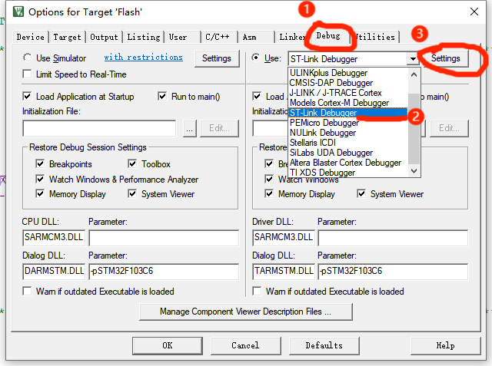
If the SW Device displays a device, it means that the debugger has successfully recognized it. Set the parameters according to the following figure and click OK.
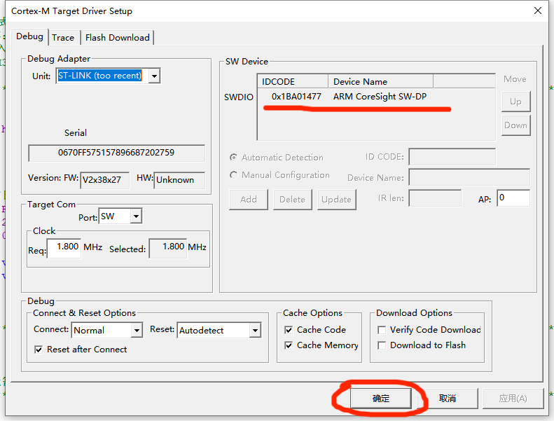
Then press Ctrl+F5 or click the debug button to start debugging:
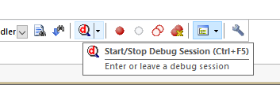
4. Module function testing
Plug in an available SIM card and then power it on. The network indicator light on the development board will turn on and off for a period of time, and the speed will increase. At the same time, the relay will turn on;
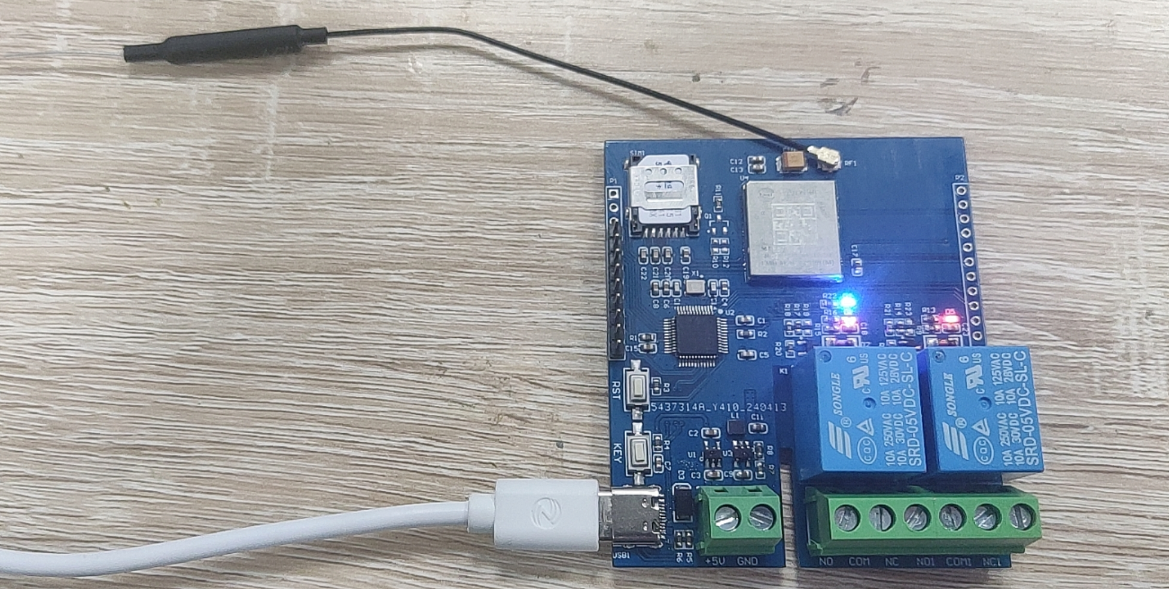
The default program is STM32 to send AT commands requesting Air780e to connect to the network. If the connection is successful, the relay will be turned on.
If the relay does not respond, it may be a networking failure. At this time, use a TTL serial port module to connect to the board, connect PA9 to RX, PA10 to TX, and GND to GND. Then open the serial port debugger, select the corresponding port and baud rate, open the serial port, press the reset button, and check the printed window data. If it displays as shown in the figure below, it means there is no problem with network access. If network access fails, please try again by changing the card.
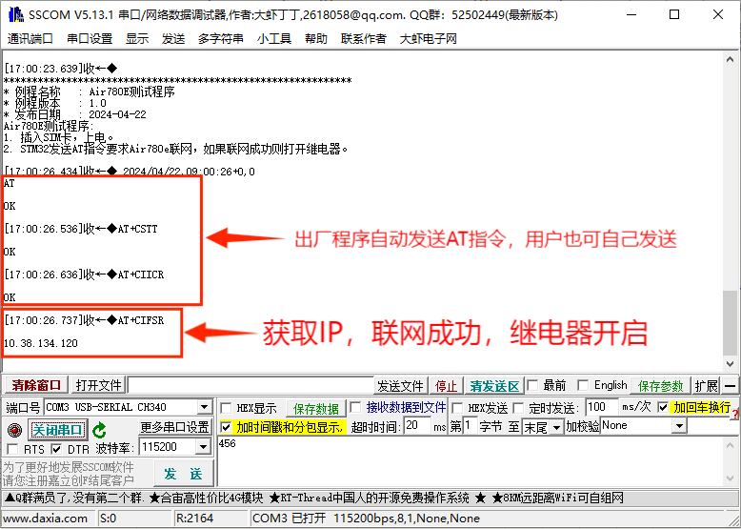

深圳市艾尔赛科技有限公司
Shenzhen LC Technology Co., Ltd.

广东省深圳市龙华区大浪街道丽荣路1号国乐科技园3栋301
Address: Room 301, Building No.3, Guole Technopark, Lirong Road, Dalang Street, Longhua District, Shenzhen 518110, China.

